NARULA INSTITUTE OF TECHNOLOGY

Department of Computer Science & Engineering

B.Tech SEM 7(AY 2025-26)

DATA MINING AND DATA WAREHOUSING LAB
(CS791C)

Name : SRIJAN DUTTA

Roll No. : 430122010110

Registration No. : 221270110238

VISION OF THE DEPARTMENT

- To empower students with cutting edge technologies in computer science and engineering

- To train the students as entrepreneurs in computer science and engineering to address the needs of the society
- To develop smart applications to disseminate information to rural people

MISSION OF THE DEPARTMENT

- To become the best computer science and engineering department in the region offering undergraduate, post graduate and research programs in collaboration with industry

- To incubate, apply and spread innovative ideas by collaborating with relevant industries and R & D labs through focused research groups.
- To provide exposure to the students in the latest tools and technologies to develop smart applications for the society

DATA MINING LAB
OBJECTIVES:
- To make the students practical exposure for various techniques of Data mining.
OUTCOMES:
- Students are able to analyze different preprocessing techniques by implementing them using programming language like C/C++.
- Students will get clear understanding of some of classification and clustering algorithms familiar in data mining.
Implement the following Data mining techniques in C/C++.
- Data cleaning techniques
  - smoothing by bin means
  - smoothing by bin medians
  - smoothing by bin boundaries
- Data Transformation techniques
  - Min-Max normalization
  - z-score normalization
  - Normalization by decimal scaling.
- Apriori algorithm.
- Classification techniques
  - Bayes classification.
  - Nearest Neighbor classification.(NNC)
- k-means clustering technique.
REFERENCES:
- Data Preparation for Data Mining ( The Morgan Kaufman Series) by Dorian pyle, First Edition.
- Data Mining algorithms by Rajan Chattamvelli, Narosa publishing house.

Exercise No: 1A

What is Data Pre-processing?
Data pre-processing is a data mining technique that involves transforming raw data into an understandable format. Real-world data is often incomplete, inconsistent, and/or lacking in certain behavior’s or trends, and is likely to contain many errors. Data pre-processing is a proven method ofresolving such issues. Data pre- processing prepares raw data for further processing. Data preprocessing is used database-driven applications such ascustomer relationship management and rule- based applications (like neuralnetworks).

What is Data Smoothing?
Data smoothing is done by using an algorithm to remove noise from a dataset. This allows important patterns to stand out. Data smoothing can be usedto help predict trends, such as those found in securities prices. The idea behind data smoothing is that it can identify simplified changes in order to help predict different trends and patterns. It acts as an aid for statisticians or traders who need to look at a lot of data that can often be complicated to digest to find patterns they would not otherwise see.

What is Smoothing by Bin Means?
In smoothing by bin means, each value in a bin is replaced by the mean value of the bin.

Example:
Perform data cleaning technique using smoothing by BIN MEANS on elements 4, 8, 15, 21, 21, 24, 25, 34, 28 whose bin size is 3.

Sort the elements and form a matrix using bin size.

4 | 8 | 15
21 | 21 | 24
25 | 28 | 34
Calculate mean value for each bin. Bin 1: 4 8
15
Bin 1 Mean: sum of elements of bin 1/bin size
= (4+8+15)/3
= 9

Bin 2: 21 21 24
Bin 2 Mean: sum of elements of bin 2/bin size
= (21+21+24)/3
= 22

Bin 3: 25 28 34
Bin 3 Mean: sum of elements of bin 3/bin size
= (25+28+34)/3
= 29

Mean Values:

9 | 9 | 9
22 | 22 | 22
29 | 29 | 29

AIM:
Write a C program to perform data cleaning techniques using smoothing by binmeans.

SOURCE CODE:
#include<stdio.h> void main()
{
int i, k, n, bin, a [50], temp, sum; float mean;
printf("Enter no of bins:"); scanf("%d",&bin);
printf("Enter no of values to be enter in each bin:"); scanf("%d",&n);
printf("Enter elements\n"); for(i=0;i<n*bin;i++)
{
scanf("%d",&a[i]);
}
printf("The given elements are\n"); for(i=0;i<n*bin;i++)
{
for(k=0;k<n*bin;k++)
{
if(a[i]<a[k])
{
temp=a[i]; a[i]=a[k]; a[k]=temp;
}
}
}
for(i=0;i<bin;i++)
{
for(k=0;k<n;k++)
{
printf("%2d\t",a[k+i*n]);
}
printf("\n");

}
printf("The mean values are\n"); for(i=0;i<bin;i++)
{
mean=0,sum=0; for(k=0;k<n;k++)
{
sum=sum+a[k+i*n];
}
mean=(float)sum/n; for(k=0;k<n;k++)
{
a[k+i*n]=mean; printf("%f\t",mean);
}
printf("\n");
}
}
OUTPUT:
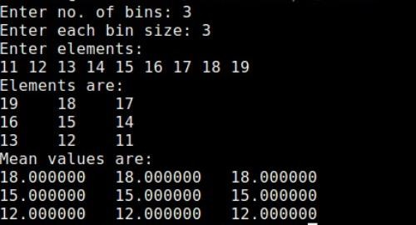

Exercise No:1B What is Smoothing by Bin Medians?
In Smoothing by Bin Medians, each value in a bin is replaced by the median value of the bin.

Example:
Perform data cleaning technique using smoothing by BIN MEDIANS on elements 4, 8, 15, 21, 21, 24, 25, 34, 28 whose bin size is 3.
Sort the elements and form a matrix using bin size.
4 8 15
21 21 24
25 28 34
Calculate median value for each bin. Bin 1: 4 8 15
Bin 1 Median: Middle value of the bin = 8 Bin 2: 21 21 24
Bin 2 Median: Middle value of the bin = 21 Bin 3: 25 28 34
Bin 3 Median: Middle value of the bin = 28 Median Values:
8 8 8
21 21 21
28 28 28

AIM:
Write a C program to perform data cleaning techniques using smoothing by bin medians.

SOURCE CODE:
#include<stdio.h> void main()
{
int i,k,n,bin,a[50],temp,sum; float median;
printf("Enter no of bins:"); scanf("%d",&bin);
printf("Enter no of values to be enter in each bin:"); scanf("%d",&n);
printf("Enter elements\n"); for(i=0;i<n*bin;i++)
{
scanf("%d",&a[i]);
}
printf("The given elements are\n"); for(i=0;i<n*bin;i++)
{
for(k=0;k<n*bin;k++)
{
if(a[i]<a[k])
{
temp=a[i]; a[i]=a[k]; a[k]=temp;
}
}
}
for(i=0;i<bin;i++)
{
for(k=0;k<n;k++)

{

printf("%2d\t",a[k+i*n]);
}
printf("\n");
}
printf("The median values are\n"); for(i=0;i<bin;i++)
{
if(n%2==0)
{

}
else
{

}
median=(float)(a[n/2-1+i*n]+a[n/2+i*n])/2;

median=a[n/2+i*n];

for(k=0;k<n;k++)
{
a[k+i*n]=median; printf("%f\t",median);
}
printf("\n");
}
}

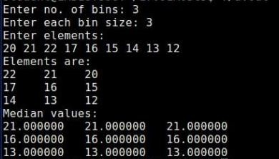
OUTPUT:

Exercise No:1C What is Smoothing by Bin Boundaries?
In Smoothing by Bin Boundaries, the minimum and maximum values in a given bin are identified as the bin boundaries.

Example:
Perform data cleaning technique using smoothing by BIN BOUNDARIES on elements 4, 8, 15, 21, 21, 24, 25, 34, 28 whose bin size is 3.
Sort the elements and form a matrix using bin size. 4 8 15
21 21 24
25 28 34
Calculate boundary value for each element in the bins by finding difference of that element with lower and upper boundary values. The boundary value which gives minimum difference will be replaced in that element place in the bin.
Bin 1: 4 8 15
Bin 1:
Min=4 and Max=15
For value 4, (4-4) < (15-4) so replace 4 with lower boundary value 4.
For value 8, (8-4) < (15-8) so replace 8 with lower boundary value 4.
For value 15, (15-4) > (15-15) so replace 15 with upper boundary value 15.
Bin 2: 21 21 24
Bin 2:
Min=21 and Max=24

For value 21, (21-21) < (24-21) so replace 21 with lower boundary value 21.
For value 21, (21-21) < (24-21) so replace 21 with lower boundary value 21.
For value 24, (24-21) > (24-24) so replace 24 with upper boundary value 24.
Bin 3: 25 28 34
Bin 3:
Min=25 and Max=34
For value 25, (25-25) < (34-25) so replace 25 with lower boundary value 25.
For value 28, (28-25) < (34-28) so replace 28 with lower boundary value 25.
For value 34, (34-25) > (34-34) so replace 34 with upper boundary value 34. Bin Boundaries:
4 | 4 15
21 | 21 24
25 | 25 34

AIM:
Write a C program to perform data cleaning techniques using smoothing by bin boundaries.

SOURCE CODE:
#include<stdio.h> void main()
{
int i,j,n,nb,a[50],temp,sum,mid,b[10][10]; printf("Enter no of bins:"); scanf("%d",&n);
printf("Enter values each bin:"); scanf("%d",&nb);
printf("Enter values\n"); for(i=0;i<n*nb;i++)
{
scanf("%d",&a[i]);
}
printf("The given values\n"); for(i=0;i<n*nb;i++)
{
for(j=0;j<n*nb;j++)
{
if(a[i]<a[j])
{
temp=a[i]; a[i]=a[j]; a[j]=temp;
}
}
}
for(i=0;i<n;i++)
{
for(j=0;j<nb;j++)
{

printf("%2d\t",a[j+i*nb]);
b[i][j]=a[j+i*nb];
}
printf("\n");
}
printf("boundaries are\n"); for(i=0;i<n;i++)
{
sum=b[i][0]+b[i][nb-1]; mid=sum/2; for(j=0;j<nb;j++)
{

}
printf("\n");
}
}
if(b[i][j]<=mid) b[i][j]=b[i][0]; else b[i][j]=b[i][n-1];
printf("%d\t",b[i][j]);

OUTPUT:
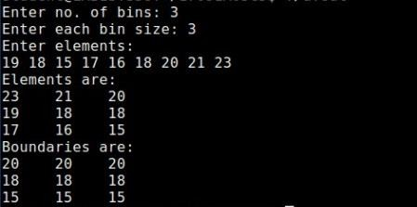

Exercise No: 2A

Aim:
Write a C program to perform Data Transformation Technique using Min-Max normalization.
Source Code: #include<stdio.h> void main()
{
float min,max,newmin,newmax,y,v; printf("Performing the min and max normalization\n"); printf("Enter min:");
scanf("%f",&min); printf("Enter max:"); scanf("%f",&max); printf("Enter New Min:"); scanf("%f",&newmin); printf("Enter New Max:"); ("%f",&newmax); printf("Enter value of v:"); scanf("%f",&v);
y=((v-min)/(max-min))*(newmax-newmin)+newmin; printf("Value of y:%f",y);
}

OUTPUT:
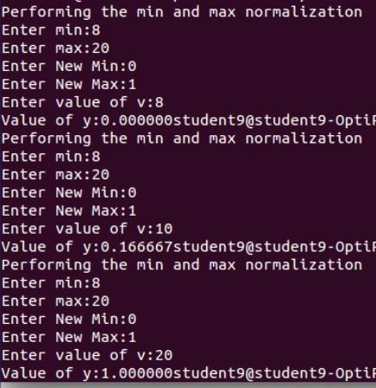

Exercise No: 2B

Aim:
Write a C program to perform Data Transformation Technique using Z- score normalization.
Source Code: #include<stdio.h> #include<math.h> int main()
{
int i,n;
float v,v1,sig,avg,sum=0,a[20];
printf("Enter number of elements to be entered\n"); scanf("%d",&n);
printf("Enter the elements\n"); for(i=0;i<n;i++) scanf("%f",&a[i]); printf("enter v value\n"); scanf("%f",&v); for(i=0;i<n;i++) sum=sum+a[i];
avg=sum/n;
printf("sum is =%f\n",sum);

printf("Avg =%f\n",avg); sum=0;
for(i=0;i<n;i++)
{
sum=sum+pow(avg-a[i],2);
}
sig=sum/n;
printf("varience is %f\n",sqrt(sig)); v1=(v-avg)/sqrt(sig);
printf("v1 value=%f\n",v1);
}

OUTPUT:
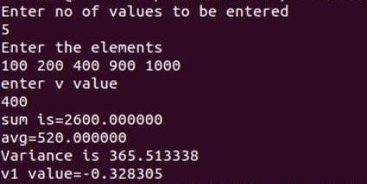

Exercise No: 2C

Aim:
Write a C program to perform Data Transformation Technique using Normalization by decimal scaling.
Source Code: #include<stdio.h> #include<math.h> #include<stdlib.h> int main()
{
float vd=2; int j=1,v;
printf("enter v value:"); scanf("%d",&v); v=abs(v); while(vd>=1)
{
vd=v/pow(10,j); j++;
}
printf("value of v' is %f\n",vd);
}

OUTPUT:
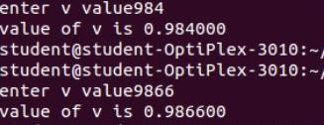

Exercise No: 3

Aim:
Write a C program to implement Apriori algorithm. Source Code:
#include<stdio.h>
static int row,col,min_freq=2;
void findFrequentSets(int items[][100],int transactions[][100],intno_of_items[],int no_of_transactions,int result_item[][100]);
void generateSubsets(int items[][100],int setCount,int result_item[][100]); void main()
{
int no_of_transactions,s=0,k=1,l=0,i,j,setCount=2,maxCount; int transactions[100][100],no_of_items[100],items[100][100]; int result_item[100][100];
printf("enter no.of transactions\n"); scanf("%d",&no_of_transactions); for(i=1;i<=no_of_transactions;i++)
{
printf("enter no.of items in transaction:%d\n",i); scanf("%d",&no_of_items[i]);
printf("enter %d items for transaction:%d\n",no_of_items[i],i); for(j=1;j<=no_of_items[i];j++) scanf("%d",&transactions[i][j]);
}
k=0;
for(i=1;i<=no_of_transactions;i++)
{
for(j=1;j<=no_of_items[i];j++)
{
for(l=1;l<=k;l++) if(items[l][1]==transactions[i][j]) break;
if(l>k)
items[++k][1] = transactions[i][j];
}
}

row=k; col=1; maxCount=k;
findFrequentSets(items,transactions,no_of_items,no_of_transactions,res ult_item); printf("\n");
for(i=1;i<=row;i++)
{
for(j=1;j<=col;j++)
printf("%d ",result_item[i][j]); printf("\n");
}
while(setCount<=maxCount)
{
generateSubsets(result_item,setCount,items);
findFrequentSets(items,transactions,no_of_items,no_of_transactions,res ult_item); for(i=1;i<=row;i++)
{
for(j=1;j<=col;j++) printf("%d ",result_item[i][j]); printf("\n");
}
setCount++;
}
}
void findFrequentSets(int items[][100],int transactions[][100],int no_of_items[],int no_of_transactions,int result_item[][100])
{
int i,j,k,l,p,q,m,count; k=1;l=1;p=1;q=1;
while(l<=row)
{
count=0; for(i=1;i<=no_of_transactions;i++)
{
m=1;
for(j=1;j<=no_of_items[i];j++)
{
if(m<=col)

{
if(transactions[i][j]==items[l][m])
{

}
else

if(m>col)
++count;
}

}

break;
m++; j=0;

if(count>=min_freq)
{
q=1;
for(m=1;m<=col;m++) result_item[p][q++]=items[l][m]; p++;
}
l++;
}
for(i=1;i<=row;i++) for(j=1;j<=col;j++) items[i][j]=0; row=p-1;col=q-1;
}
void generateSubsets(int items[][100],int setCount,int result_item[][100])
{
int i=1,j,k,l,count=0,newRow=0,newCol=0,p,q,m,n,r=1,b[row+1]; while(i<=row)
{
j=i; k=1;
while(j<=row)
{
if(j==row)
{
if(count+1==2)
{

b[k++]=j; newRow++; newCol=1; for(l=1;l<k;l++)
{
for(p=1;p<=col;p++)
{
for(q=1;q<newCol;q++) if(result_item[newRow][q]==items[b[l]][p]) break;
if(q>=newCol) result_item[newRow][newCol++]=items[b[l]][p];
}
}
if(newCol-1!=setCount)
{

}
else
{
for(m=1;m<newCol;m++) result_item[newRow][m]=0; newRow--;

for(m=1;m<newRow;m++)
{
r=1;
for(n=1;n<newCol;n++)
{
if(result_item[m][n]==result_item[newRow][r])
{
n=1; r++;
if(r>setCount)
{
for(p=1;p<newCol;p++) result_item[newRow][p]=0; newRow--;
break;
}
}
if(n<=setCount)

break;
}
}
k--;
b[k]=0;
}
if(k-1<=1)
{

}
k--;
count=0; for(l=1;l<k;l++) b[l]=0;
break;

count--;
j=b[k]+1;
b[k]=0;
}
else if(count+1<2)
{
count++; b[k++]=j; j++;
}
else if(count+1==2)
{
b[k++]=j; newRow++; newCol=1; for(l=1;l<k;l++)
{
for(p=1;p<=col;p++)
{
for(q=1;q<newCol;q++) if(result_item[newRow][q]==items[b[l]][p]) break;
if(q>=newCol) result_item[newRow][newCol++]=items[b[l]][p];
}
}

if(newCol-1!=setCount)
{
for(m=1;m<newCol;m++) result_item[newRow][m]=0; newRow--;
}
else
{
for(m=1;m<newRow;m++)
{
r=1;
for(n=1;n<newCol;n++)
{
if(result_item[m][n]==result_item[newRow][r])
{
n=1; r++;
if(r>setCount)
{
for(p=1;p<newCol;p++) result_item[newRow][p]=0;
newRow--; break;
}
}
}
if(n<=setCount) break;
}
}
k--;
b[k]=0; j++;
}
else j++;
}
i++;
}
row=newRow; col=newCol-1;
}

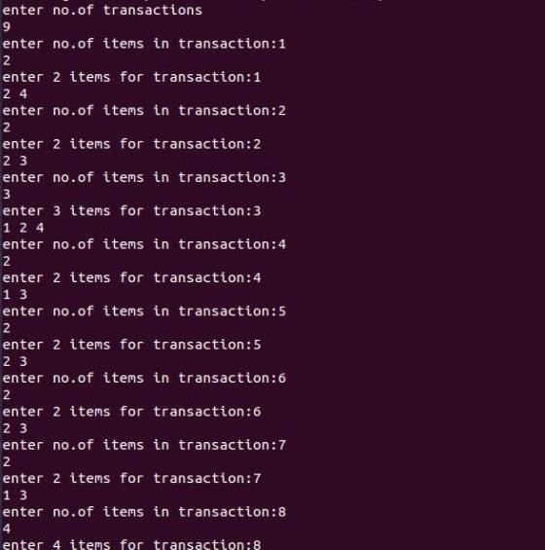
OUTPUT:

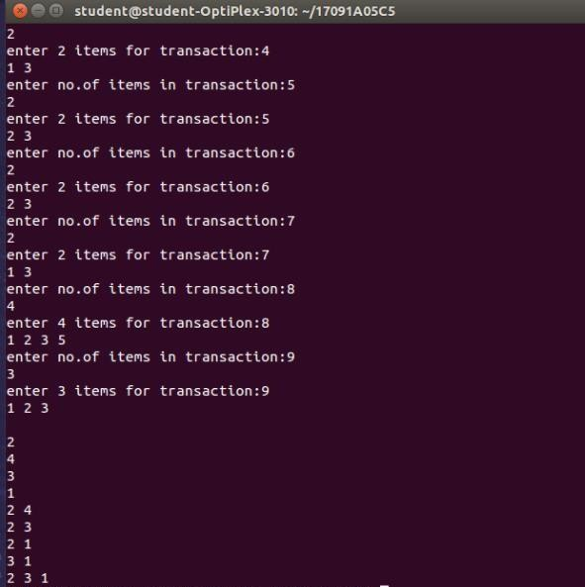

Exercise No: 4A

Aim:
Write a C program to implement Bayes classification technique. Source Code:
#include<stdio.h> #include<string.h> void class(int ,int);
char cls[10][20],titems[50][20][20],attr[10][20]; int pcount[20],count[10],fc=0,c=0;
float p[10],prob[20],pre[10],result[10]; int main()
{
char tup[15][20];
int i,j,n,tuples,k,ans=0,t=0; printf("enter no of attributes:"); scanf("%d",&n);
printf("enter no of tuples:"); scanf("%d",&tuples); printf("enter %d attributes\n",n); for(i=0;i<n;i++) scanf("%s",attr[i]); for(i=0;i<tuples;i++)
{
printf("enter tuple%d\n",i+1); for(j=0;j<n;j++) scanf("%s",titems[i][j]);
}
printf("enter test tuple\n"); for(i=0;i<n-1;i++)

scanf("%s",tup[i]); class(n,tuples); for(i=0;i<fc;i++) p[i]=count[i]/(float)tuples;
for(i=0;i<fc;i++)
{
for(j=1;j<n-1;j++)
{
pcount[j]=0; for(k=0;k<tuples;k++)
{
if(strcmp(titems[k][j],tup[j])==0 &&strcmp(cls[i],titems[k][n- 1])==0) pcount[j]+=1;
}
if(pcount[j]!=0 && t==0) prob[c++]=pcount[j]/(float)count[i]; else
{
t=1;
prob[c++]=(pcount[j]+1)/(float)count[i];
}
}
}
j=0;
for(i=0;i<fc;i++)
{
pre[i]=1.0;
for( ;j<((i+1)*(c/fc));j++) pre[i]*=prob[j];
}
for(i=0;i<fc;i++)
{
result[i]=pre[i]*p[i];
if(i>0 && result[i]>result[i-1]) ans=i;
}
printf("The test tuple belongs to %s class",cls[ans]);
}

void class(int p,int q)
{
int i=0,k,t=0; strcpy(cls[fc++],titems[0][p-1]); for(i=1;i<q;i++)
{
t=0;
for(k=0;k<fc;k++)
{
if(strcmp(titems[i][p-1],cls[k])==0)
{
t=-1;
break;
}
}
if(t!=-1) strcpy(cls[fc++],titems[i][p-1]);
}
for(i=0;i<fc;i++)
{
count[i]=0; for(k=0;k<q;k++)
{
if(strcmp(titems[k][p-1],cls[i])==0) count[i]+=1;
}
}

OUTPUT:
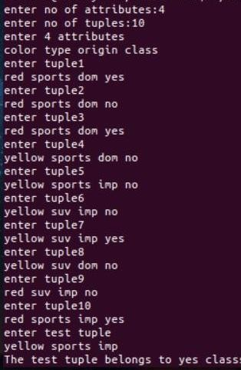

Exercise No: 4B

Aim:
Write a C program to implement Nearest Neighbor Classification technique Source Code:
#include<stdio.h> #include<stdlib.h> #include<math.h> int tuples,attr; float near[20];
void NNC(int d[20][20],int t[1][20]) ; int isNear()
int main()
{
int i,j,k,data[20][20],test[1][20],s; printf("enter no of tuples:"); scanf("%d",&tuples); printf("enter no of attributes:"); scanf("%d",&attr);
printf("enter %d tuples\n",tuples); for(i=0;i<tuples;i++)
{
for(j=0;j<attr;j++)
{
scanf("%d",&data[i][j]);
}
}
printf("enter test tuple\n");

for(i=0;i<attr;i++)
{
scanf("%d",&test[0][i]);
}
printf("enter k value:"); scanf("%d",&k); NNC(data,test);
printf("The nearest neighbours are\n"); for(i=0;i<k;i++)
{
s=isNear(); printf("("); for(j=0;j<attr;j++)
{
printf("%3d",data[s][j]);
}
printf(")\n");
}
}
void NNC(int d[][20],int t[][20])
{
int i,j,sum=0; for(i=0;i<tuples;i++)
{
for(j=0;j<attr;j++)
{
sum+=((d[i][j]-t[0][j])*(d[i][j]-t[0][j]));
}
near[i]=sqrt(sum);

sum=0;
}
}
int isNear()
{
float t=near[0]; int s=0,i;
for(i=1;i<tuples;i++)
{
if(t>=near[i] && near[i]!=999)
{
t=near[i]; s=i;
}
}
near[s]=999; return s;
}

OUTPUT:
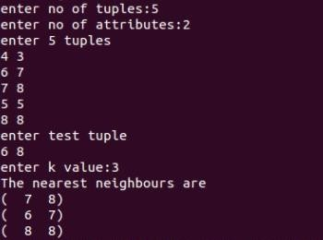

Exercise No: 5

Aim:
Write a C program to implement k-means clustering algorithm. Source Code:
#include<stdio.h> void main()
{
int i1,i2,i3,t1,t2,m1,m2,om1,om2; int k0[10],k1[10],k2[10];
printf("Enter 10 numbers:"); for(i1=0;i1<10;i1++)
{
scanf("%d",&k0[i1]);
}
printf("Enter intial mean 1:"); scanf("%d",&m1); printf("Enter intial mean 2:"); scanf("%d",&m2);
do
{
om1=m1; om2=m2; i1= i2=i3=0;
for(i1=0;i1<10;i1++)
{
t1=k0[i1]-m1;

if(t1<0)
{
t1=-t1;
}
t2=k0[i1]-m2; if(t2<0)
{
t2=-t2;
}
if(t1<t2)
{
k1[i2]=k0[i1]; i2++;
}
else
{

} t2=0;
k2[i3]=k0[i1]; i3++;
}

for(t1=0;t1<i2;t1++)
{
t2=t2+k1[t1];
}

m1=t2/i2; t2=0;
for(t1=0;t1<i3;t1++)
{
t2=t2+k2[t1];
}
m2=t2/i3; printf("\nCluster 1:"); for(t1=0;t1<i2;t1++)
{
printf("%d ",k1[t1]);
}
printf("\nm1=%d",m1); printf("\nCluster 2:"); for(t1=0;t1<i3;t1++)
{
printf("%d ",k2[t1]);
}
printf("\nm2=%d",m2); printf("\n ");
}
while(m1!=om1 && m2!=om2); printf("\nClusters created");
}

OUTPUT:
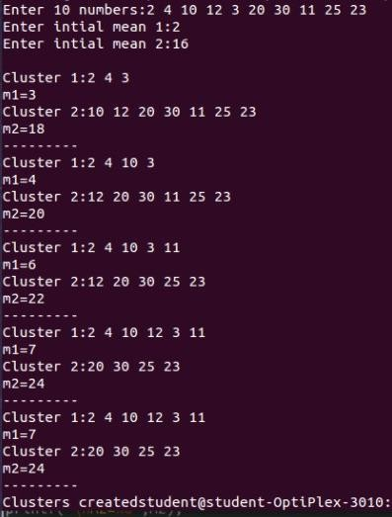

Evaluation Procedure for Internal Laboratory Examinations:
- Of the 25 marks for internal, 10 marks will be awarded for day-to-day work and 10 marks to be awarded for the Record work and 5 marks to be awarded by conducting an internal laboratory test.
- Concerned Teachers have to do necessary corrections with explanations.
- Concerned Lab teachers should enter marks in index page.
- Internal exam will be conducted by two Staff members.

BINGSHATI MONDAL
Professor Dept. of CSE.

Evaluation Procedure for External Laboratory Examinations:
- For Practical subjects there is a continuous evaluation during the semester for 25 Sessional marks and 50 end examination marks.
- The end examination shall be conducted by the teacher concerned (Internal Examiner) and another External Examiner, recommended by Head of the Department with the approval of principal.

Evaluation procedure for external lab examination:
- Procedure for the program 20M
- Execution of the program 15M
- Viva voce 15M

Total 50M

BINGSHATI MONDAL
Professor Dept. of CSE.

